Date: 07.03.2025
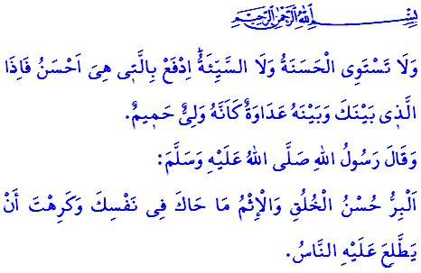
RAMADAN: THE MONTH OF GOODNESS
Honorable Muslims!
After our Prophet (saw) migrated to Madinah, many people began arriving in this blessed city to learn about Islam. One of them was Nawwas, who was honored with Islam at a very young age. One day, Nawwas (ra) asked our beloved Prophet (saw) about the nature of good and evil. The Messenger of Allah (saw) gave him this wise answer: “Righteousness is good character and sin is what gnaws at your conscience and that which you dislike for other people to become aware of.”
Dear Believers!
According to our sublime religion, Islam, goodness is not merely a word, attitude, or behavior that can be reduced to mere form or displayed for show. Goodness is the purpose of our life, the essence of our faith and servitude. It is our greatest wealth, our most valuable legacy. It represents the pinnacle of morality and the strongest foundation of social harmony.
Our Lord Almighty describes true goodness in Verse 177 of Surah al-Baqarah as follows: Rather, the righteous are those who believe in Allah, the Last Day, the angels, the Books, and the prophets; who give charity out of their cherished wealth to relatives, orphans, the poor, ˹needy˺ travellers, beggars, and for freeing captives; who establish prayer, pay alms-tax, and keep the pledges they make; and who are patient in times of suffering, adversity, and in ˹the heat of˺ battle.
Esteemed Muslims!
There is always a good deed that each of us can perform—with our hands, our words, our wealth, our knowledge, our profession, and our experience. Sometimes, goodness means being a dutiful child, a loyal spouse, a compassionate parent, or a person who greets others with a smile and kind words. At other times, goodness means greeting everyone with kindness, regardless of their age. It is taking the time to ask about their well-being. It is showing love to a child and respect to an elderly person. It is showing mercy to every living creature. It is refraining from harming anyone with our hands or words.
Esteemed Believers!
Unfortunately, we are living in an age where goodness is being diminished, and evil is being encouraged. War, anger, hatred, enmity, and violence are increasing daily in our world due to those who lack goodness. The oppressors who thrive on evil continue to massacre innocents in Islamic lands, especially in Gaza. They deny our brothers and sisters even their most basic needs. What falls upon us is to do more good and not leave the oppressed to the conscience of the oppressors, as the verse urges, وَتَعَاوَنُوا عَلَى الْبِرِّ وَالتَّقْوٰىۖ “Cooperate with one another in goodness and righteousness.” It is to keep the products of those who support the oppressors away from our tables, our homes, our workplaces, and, in short, our lives.
Dear Muslims!
Goodness has a transformative power. Our Lord Almighty states, “Good and evil cannot be equal. Respond ˹to evil˺ with what is best, then the one you are in a feud with will be like a close friend.” So, let us use the month of Ramadan as an opportunity to heal resentments and end the grudges among us. Let us be forgiving and merciful. Let us remove the hatred and envy that harm our brotherhood, unity, and solidarity from our lives. Let us open our hearts to our brothers and sisters, and our doors to our neighbors, this Ramadan and always. The Messenger of Allah (saw)says, إِنَّ اللّٰهَ كَتَبَ الْإِحْسَانَ عَلَى كُلِّ شَيْءٍ “Indeed, Allah has ordained excellence in everything.” So, let us start doing good, beginning with our family. Let us bless our homes with goodness. Let us plant seeds of goodness in the hearts of our children. Let us extend our hand of goodness to our brothers and sisters who are immersed in sin, involved in evil, or have lost hope in life. Let us do good so that our lives may flourish. Let us do good so that our world can change. May our capital be goodness and our reward be paradise, this Ramadan and always.

I would like to conclude this Friday’s khutbah with our Prophet’s (saw) following supplication: “O Allah! Make my life a means of accumulating good, and make death a respite for me from all evil.”

Muslim, Birr, 15.
Baqarah, 2/177.
Ma’idah, 5/2.
Fussilat, 41/34.
Tirmidhi, Diyat, 14.
Muslim, Dhikr, 71. General Directorate of Religious Services

